Experiment No: 07 Machine Learning

Aim:
Compute confusion matrices and F1 score for a diabetes prediction model (Pima dataset).

Objective:
• To apply Logistic Regression for binary classification on medical data.
• To evaluate the performance of a model using confusion matrix and F1 score.
• To visualize model results using a confusion matrix heatmap.
• To interpret performance metrics like precision, recall, and F1 score.

Prerequisites:
• Software: Python 3.x with pandas, scikit-learn, seaborn, matplotlib installed.
• Hardware: A computer with at least 4 GB RAM.
• Skills: Understanding of Logistic Regression and evaluation metrics in ML.

Theory:
In classification tasks, the confusion matrix is a crucial tool to evaluate model performance. It displays the counts of true positives, true negatives, false positives, and false negatives. From these values, metrics such as precision, recall, and F1 score are derived.
The F1 score is the harmonic mean of precision and recall, providing a balance between the two. It is particularly useful when dealing with imbalanced datasets.
In this experiment, Logistic Regression is applied on the Pima diabetes dataset. This model estimates the probability of a patient being diabetic based on medical attributes. Feature scaling ensures numerical stability and helps the model converge effectively.

Apparatus/Software Requirements:
• Python IDE (Jupyter Notebook, VS Code, etc.).
• Required Python libraries: pandas, numpy, scikit-learn, seaborn, matplotlib.
• Pima Diabetes Dataset (CSV format).

Procedure:
Step 1: Load the Pima Diabetes dataset and inspect the structure.
Step 2: Split features and target variable (Outcome).
Step 3: Divide the data into training and testing sets.
Step 4: Apply feature scaling to improve model performance.
Step 5: Train Logistic Regression model on the training data.
Step 6: Predict outcomes on the test data.
Step 7: Compute confusion matrix and F1 score for evaluation.
Step 8: Plot the confusion matrix as a heatmap using seaborn.
Step 9: Print classification report for detailed analysis.

Program Code:
import pandas as pd
import numpy as np
import seaborn as sns
import matplotlib.pyplot as plt
from sklearn.model_selection import train_test_split
from sklearn.preprocessing import StandardScaler
from sklearn.linear_model import LogisticRegression
from sklearn.metrics import confusion_matrix, f1_score, classification_report
# Load dataset
df = pd.read_csv("Pima_diabetes.csv") # Replace with your actual dataset path
# Split features and target
X = df.drop('Outcome', axis=1)
y = df['Outcome']
# Train-test split
X_train, X_test, y_train, y_test = train_test_split(X, y, test_size=0.2, random_state=42)
# Scale features (important for logistic regression)
scaler = StandardScaler()
X_train = scaler.fit_transform(X_train)
X_test = scaler.transform(X_test)
# Train model
model = LogisticRegression()
model.fit(X_train, y_train)
# Predict
y_pred = model.predict(X_test)
# Metrics
cm = confusion_matrix(y_test, y_pred)
f1 = f1_score(y_test, y_pred)
print("Confusion Matrix:\n", cm)
print("F1 Score:", f1)
# Normalized confusion matrix (percentages)
cm_percent = cm.astype('float') / cm.sum(axis=1)[:, np.newaxis] * 100
# Plot confusion matrix
plt.figure(figsize=(6,5))
sns.heatmap(cm, annot=True, fmt='d', cmap='cool', cbar=False, square=True,
xticklabels=['Not Diabetic (0)', 'Diabetic (1)'],
yticklabels=['Not Diabetic (0)', 'Diabetic (1)'])
plt.title(f'Confusion Matrix (F1 Score = {f1:.2f})', fontsize=13)
plt.xlabel('Predicted Label')
plt.ylabel('True Label')
plt.show()
# Print classification report
print("Classification Report:\n", classification_report(y_test, y_pred))

Expected Output:
- Confusion Matrix displaying predicted vs actual outcomes & F1 Score printed on the console.

- Heatmap visualization of the confusion matrix.
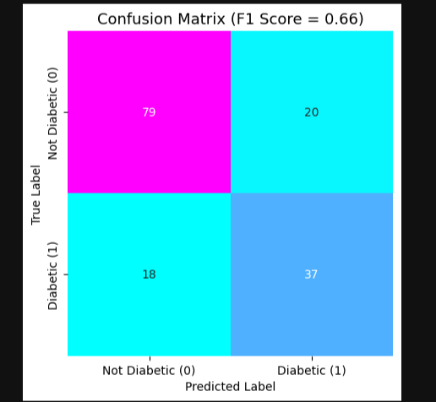

- Classification report showing precision, recall, and F1 for each class.
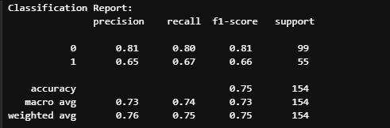

Observations:
The Logistic Regression model effectively classifies diabetic and non-diabetic cases. The confusion matrix shows correct and incorrect predictions, while the F1 score summarizes the model’s overall performance. Visualization helps in understanding class-wise accuracy and misclassification rates.

Conclusion:
This experiment demonstrates model evaluation using confusion matrix and F1 score. These metrics provide comprehensive insights into classifier performance, especially in medical datasets like Pima Diabetes.

Viva Questions:
• What is a confusion matrix?
• How is the F1 score calculated?
• Why is feature scaling important in Logistic Regression?
• What does a high F1 score indicate?
• How can the confusion matrix be used to identify model weaknesses?

